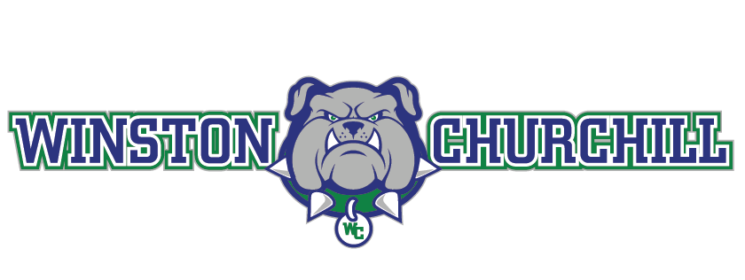

Dear Bulldog Parents:

As the summer draws to a close, our thoughts are finally drawn to a normal year filled with athletic contests for our student athletes. Our athletes will brave the summer heat – throwing, kicking, catching and hitting balls and running, jumping and training with teammates in preparation for fall competition. Our freshman and sophomores will finally experience a normal fall sports season.

Churchill coaches are actively preparing for the season and will soon begin preparing our student athletes for competition. It is the continued commitment of the Booster Club to support our student athletes and coaches – through the work of many active and dedicated parent volunteers.

Athletics are instrumental to our children’s mental and physical well-being. We have enjoyed seeing our athletes running through our neighborhoods; meeting up to train for their particular sport; and hearing about creative ways they’ve been able to stay in shape. Now it is time to get back to inter-scholastic competition.

The Booster Club, despite the pandemic last year resourced many new things for the return of competition at Churchill this year. Our athletes will see a new Bulldog logo on the press box at the stadium. There will be a new concession and ticket booth near the Field Hockey, Baseball and Softball entrances. There is all new refrigeration in our concession stands and the LAX wall has been painted to honor our 2022 student athletes.

The Booster Club and the Churchill Athletic Department is focused on ensuring our athletes will continue to have all of the necessary things to compete at the highest possible level during their season. Given the budgetary challenge that the Athletic Department will face during the coming year, the Booster Club will play a critical role in providing supplemental resources to help offset these economic challenges. This, coupled with the existing financial responsibility that the Booster Club has in resourcing the field maintenance for the Churchill fields, it is now time to kick off the Booster Club membership campaign. Your membership in the Booster Club is critical to ensuring Bulldog sports have these necessary resources.

Our goal is to have active participation from all Bulldog team families – as well as support from our community partners – who continue to generously support our programs. As an incentive, the Booster Club will donate 15% of each team’s revenue back to a team’s individual account. In 2020/21 the Booster Club donated back more than $5,200 to the respective team’s accounts. Please encourage parents of returning athletes – and freshman families – to join us in our campaign kick-off. As an added challenge, any team that has 100% participation from families, will receive a $300 bonus credited back to their team account. This is a critical year and we cannot provide the critical support needed to launch sports programs without your help. Sign up here to support our Bulldogs!

Thank you in advance for your help and support. We wish our families health and safety as we kick off the 2021-2022 athletic school year.

Sincerely,

Rob Demske Jesse Smith
President Athletics Specialist
WCHS Booster Club WCHS

